EXPERIMENT 2

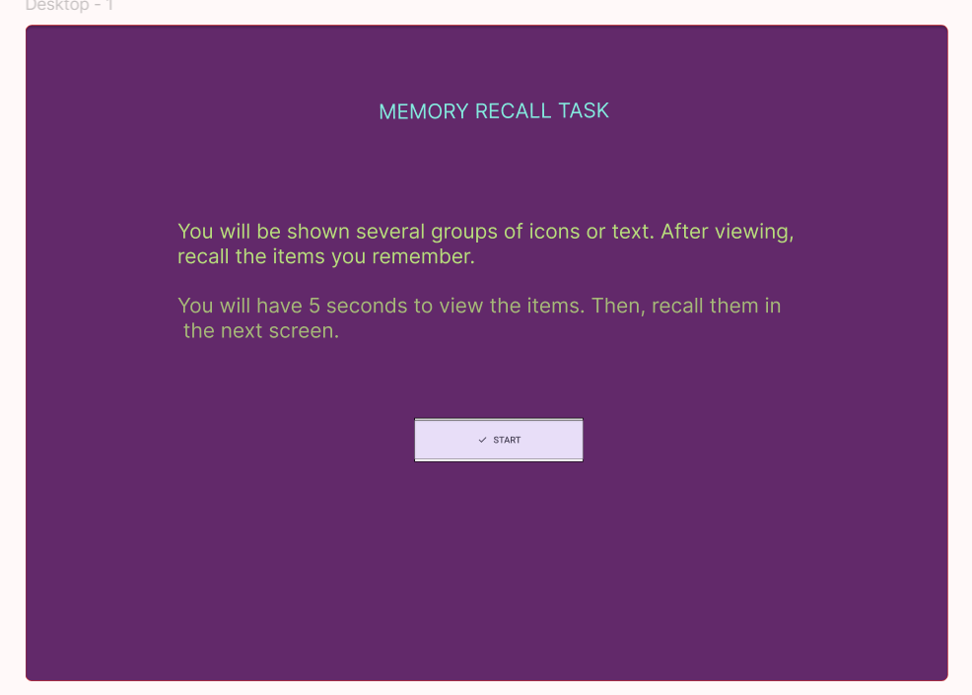

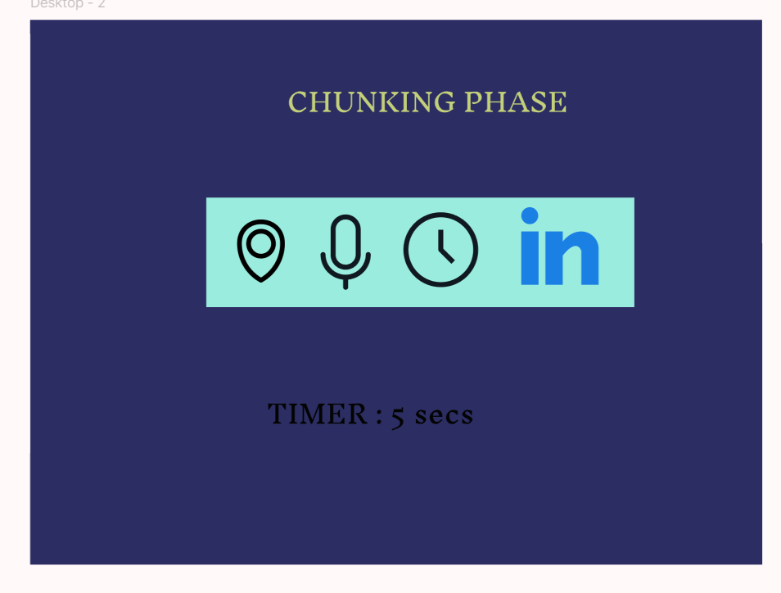

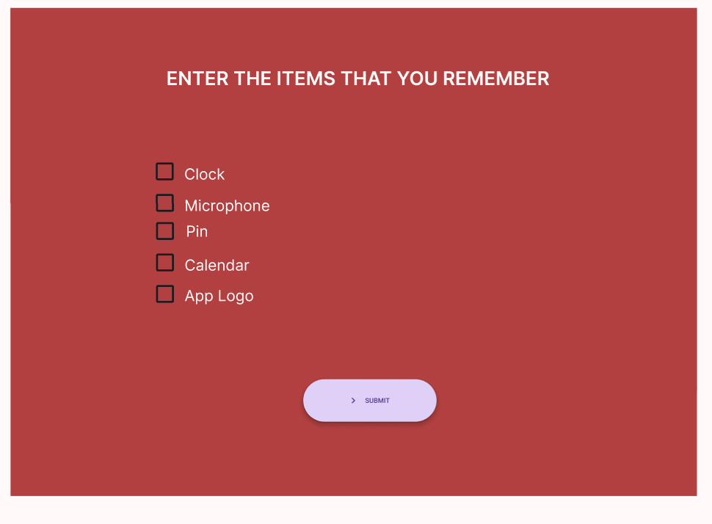

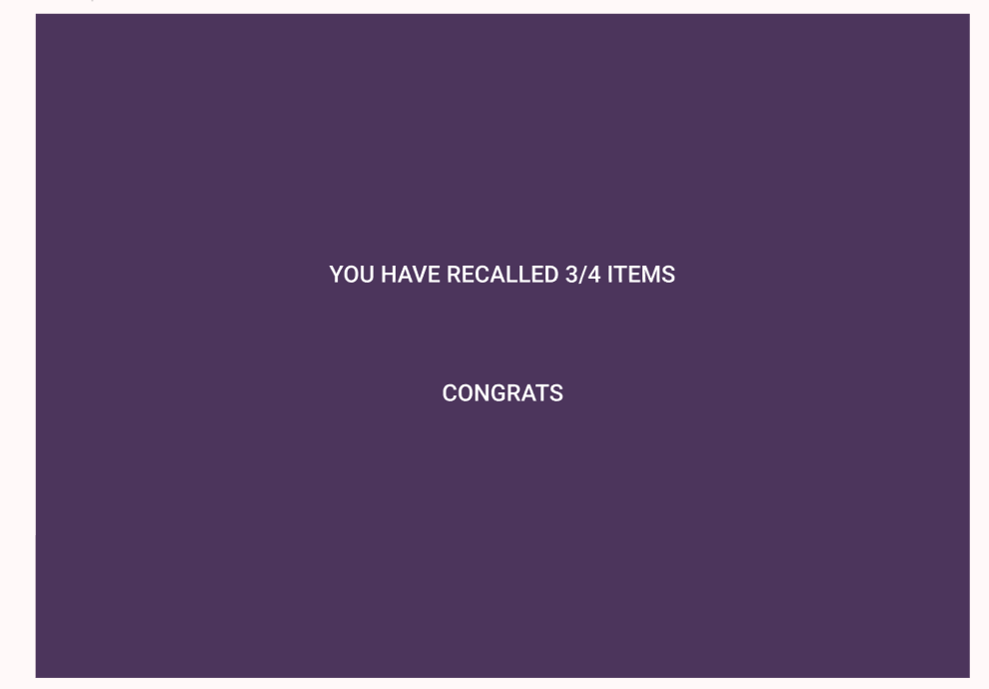

LINK: https://www.figma.com/proto/D2f1klhbGtiXG1qKwfljFP/EXP-2?node-id=12-77&p=f&t=SOgG9NJw9R33IjZP-1&scaling=min-zoom&content-scaling=fixed&page-id=0%3A1&starting-point-node-id=1%3A2